Project Design Phase-II
Data Flow Diagram & User Stories
Date | 08 October 2026
Team ID | [TEAM ID]
Project Name | Auto Ticket Classification Using ServiceNow Flow Designer
Maximum Marks | 4 Marks

Data Flow Diagrams:
A Data Flow Diagram (DFD) is a traditional visual representation of the information flows within a system. The diagrams below show how ticket data moves between the Caller, the School IT Ticket table, the Flow Designer flow and the IT helpdesk staff.
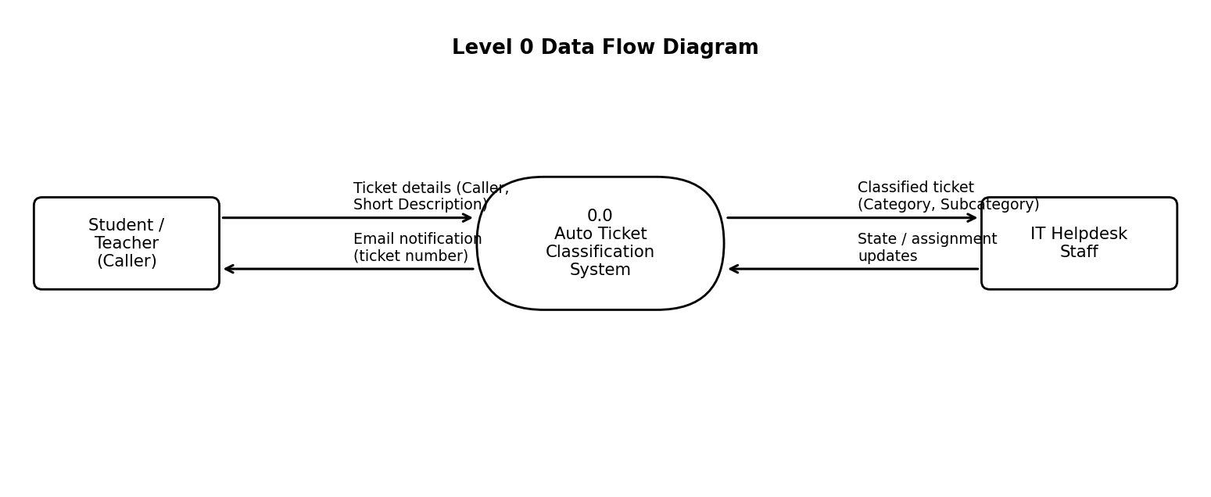
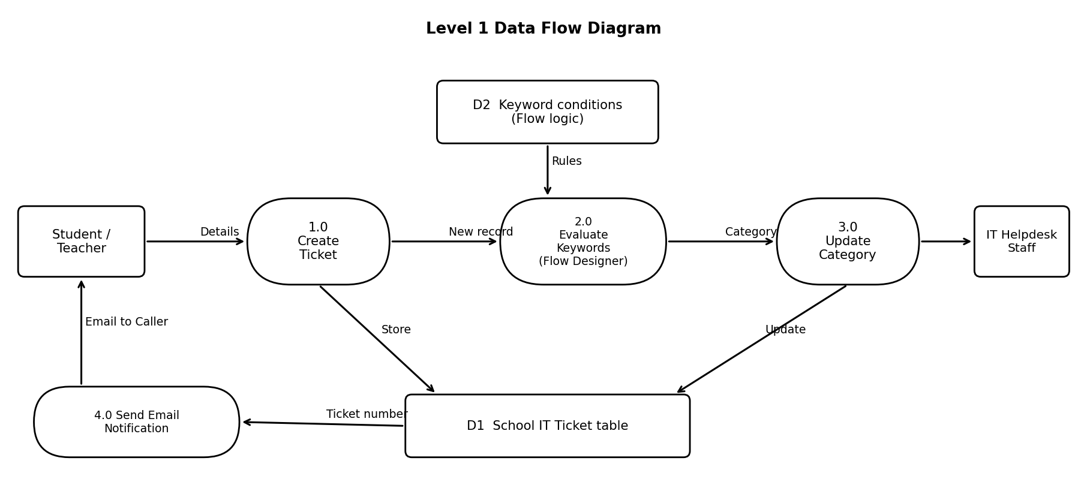
Description: In process 1.0 the Caller submits the Caller and Short Description details, which are stored in the School IT Ticket table (D1). In process 2.0 the Flow Designer flow reads the new record and evaluates keywords using its conditions (D2). In process 3.0 the Category and Subcategory fields of the record are updated. In process 4.0 an email containing the ticket number is sent to the Caller. IT helpdesk staff then view the classified ticket.
User Stories
Use the below template to list all the user stories for the product.
User Type | Functional Requirement (Epic) | User Story Number | User Story / Task | Acceptance criteria | Priority | Release
Administrator | Requirement Analysis | USN-1 | As an administrator, I document the business use case and requirements so that the scope of the automation is clear. | Six business requirements are documented | High | Sprint-1
 | Configuration Management | USN-2 | As an administrator, I create the Project Update Set and make it current so that all changes are captured. | Update set is In progress, in the Global application and set as current | High | Sprint-1
 | Documentation | USN-3 | As an administrator, I record the navigation steps in picture view so that the configuration can be repeated. | Navigation steps with screenshots are available | Medium | Sprint-1
Student / Teacher (Caller) | Ticket Creation | USN-4 | As a caller, I can create a ticket in the School IT Ticket table by entering my name and a short description. | The ticket is saved with an auto-generated number | High | Sprint-1
Administrator | Data Structure | USN-5 | As an administrator, I create all required fields with the correct data types and choices. | Fields and choice lists appear correctly on the form | High | Sprint-2
 | Dependent Choice | USN-6 | As an administrator, I make Subcategory choices depend on the selected Category. | Only valid Subcategory options are listed for a Category | Medium | Sprint-2
IT Helpdesk Staff | Automatic Classification | USN-7 | As IT staff, I want a flow to run when a ticket is created so that the ticket text can be analysed automatically. | The flow is triggered for every new ticket | High | Sprint-2
 |  | USN-8 | As IT staff, I want keywords in the ticket to set the Category and Subcategory (Wi-Fi to Network, Projector to Hardware, Password or Login to Access, Slow or Hanging to Performance). | Category and Subcategory are updated according to the keyword | High | Sprint-3
Student / Teacher (Caller) | Email Notification | USN-9 | As a caller, I receive an email when my ticket is created. | Email with the ticket number is received | Medium | Sprint-3
 | Ticket Creation | USN-10 | As a caller, I do not have to select the Category or Subcategory myself. | Category and Subcategory are filled in without manual input | High | Sprint-3
Administrator | Testing, Validation & Security | USN-11 | As an administrator, I validate the automation and restrict access so that only authorized users can modify ticket data. | All test cases pass; unauthorized modification is blocked | High | Sprint-4
 | Deployment & Conclusion | USN-12 | As an administrator, I mark the Project Update Set as Complete and conclude the project. | Update set state is Complete | Medium | Sprint-4

